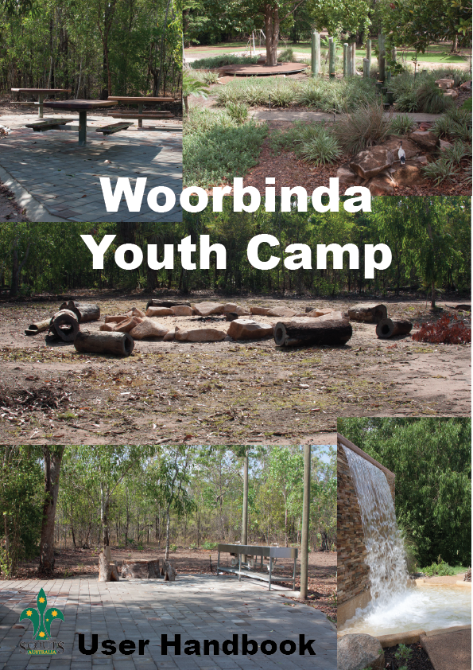

General Information

- An Introduction to Woorabinda 4
- Contact Information 4
- History of Howard Springs 5
- History of Woorabinda 5
- How to use this Handbook 6

Planning Your Stay

- The Top End Climate 6
- How to Get There 6
- Campground Overview 6
- Fees and Charges 7
- Distances 7
- Group Size 7
- Booking Procedure 8
- Cancellations 8

Site Information

- Site Access 9
- Ablution Block 10
- Outdoor Kitchen 10
- Camping Area 11
- Open Campfire 12
- Power 12
- Water 12
- Miscellaneous Items 12

Health and Safety

- First Aid Kit 13
- Heat Illness 13
- Drinking Water 13
- Biting Insects 13
- Swimming 14
- Tropical Diseases 15
- Crocodiles 15
- Communications 15
- Emergency Facilities 15
- Emergency Evacuation 15

Your Responsibilities

- Things to Bring 16
- During Your Stay 16
- When You Leave 17

Educational Opportunities

- Natural Environment Overview 17
- Activities Overview 20

Bushfire Safety Procedure

- Bushfire Safety Plan 21
- Off site safety advice 22
- Bushfire detection 23
- Emergency muster Points 24

General Information

Introduction to Woorabinda

Woorabinda is a 16ha campground located within the boundaries of the Howard Springs Nature Park. Howard Springs is one of the Northern Territory’s most accessible Nature Parks, located on the edge of the Greater Darwin Rural area - only 30 minutes from Darwin City and 5 minutes from Palmerston. Comprising of approximately 283ha, the Howard Springs Nature Park is a preserved bushland oasis centered around a spring fed waterhole teaming with Aquatic life and comprises a mix of dry woodland, monsoon forest, wet season paperbark swamps and riverine habitats.

Woorabinda Youth Camp is a dedicated facility in which to deliver quality outdoor recreation and educational experiences with a prime focus to develop life skills and enrich the lives of young people and the wider community. The facility is available for use to community based youth organisations and education providers.

The Northern Territory Branch of Scouting Australia (Scouts NT) acquired the Lease of Woorabinda Youth Camp in 2014 with permission to develop educational camping and outdoor recreation facilities at the site. Scouting Australia is an inclusive, community based, non-profit, volunteer organisation and a registered Vocational Education and Training provider. Scouts NT are responsible for the management and upkeep of the Woorabinda Youth Camp.

A master plan for redevelopment of Woorabinda is in progress over the next 5 years and will incorporate the construction of a large kitchen/dining facility, new amenity facilities with disabled access, dormitories, orienteering course, low ropes course and interpretative bush tucker and bush medicine trail. Development of these projects as well as the regular maintenance and certification of facilities rely on the goodwill and support of the community. For more information or to assist in development or land care and conservation projects please contact the voluntary caretaker at gl.woorabinda@nthq.scouts.com.au

Contact Information

Any enquiries regarding use and hire of the grounds should be directed to:

Scouts Northern Territory Branch
22 Bauhinia Street
Nightcliff NT 0811
Ph (08) 89480994
Email info@scoutsnthq.com.au
Volunteer Caretaker: Email gl.woorabinda@nthq.scouts.com.au
History of Howard Springs

The Park lies within the area traditionally occupied by the Larrakia people. There is a recorded sacred site within the Park and it is likely that the spring would have had some importance to the local Aboriginal people. The European history of the Springs began in the late 1800's when they were encompassed by large pastoral leases in this area. In the 1910's the Springs themselves came into focus as a solution to Darwin's unreliable water supply.
Eventually in 1939, after a community petition and delays caused by the Depression, water from the Springs was piped to railway dams, overhead tanks in Darwin, and Vestey's meat works. This arrangement served as a stop-gap measure until Manton Dam was completed in 1942. A road connecting this area with Darwin was built as part of this project.
During the Second World War, rest and recreation camps for up to 120 men were set up here for servicemen from USA and Australia. The weir was built in 1944 by the Royal Australian Engineers to improve the swimming hole.
In 1957 Howard Springs became the Northern Territory's first Reserve under the NT Reserves Board, now the Parks and Wildlife Commission.

History of Woorabinda

In 1962 the Darwin Administrator - Mr Nott, agreed to grant a special lease on a block of land near the Howard Springs to the Darwin Girl Guides. An amenities block was quickly built by volunteers (as it still stands today) and was officially opened by the World Chief Lady Baden-Powell in 1967 on her second visit to Australia. Use of the site by Girl Guides and Scouts continued until the mid 1990’s. A detailed history is available on the Scouts NT website: www.nt.scouts.com.au

How to use this handbook

This handbook is designed to provide information on facilities and educational opportunities offered at Woorabinda Youth Camp. It is organised into main sections:

- Planning Your Stay
- Site Information
- Health and Safety
- Educational Opportunities

Use this handbook to aid your planning to provide a safe and enjoyable outdoor recreation and environmental education experience.

Planning Your Stay

The Top End Climate

The climate of the Northern Territory’s Top End is divided into two distinct seasons, the Wet and the Dry. The Dry Season (April – September) is typified by warm days with cool nights and low humidity. Temperatures range from a minimum of around 20 degrees to a maximum of around 28 – 30 degrees. The Wet Season (October – April) brings heavy monsoon rain showers and very high humidity. Temperatures range from a minimum of around 25 degrees to a maximum of around 34 – 35 degrees. Temperature peaks during the day of up to 38 - 39 degrees can be experienced during the build up months to the wet season in October/ November.

How to Get There

The Park is approximately 35 km south of Darwin city. Follow the Stuart Highway south and turn left onto Howard Springs Road at the traffic lights. Drive approximately 4.5km to the Howard Springs Nature Park entrance. Once inside the park follow the signs to the Springs and follow the road round to the right. The camp ground gateway is signed on the right hand side of the road, and located opposite the water park / sensory playground. Enter the gate and follow the dirt road to the campsite.

Campground Overview

The Woorabinda Campground offers accessible, enjoyable and safe opportunities to experience and learn about the Top End and its natural environment. The site is located a short 300m walk from the waterhole and recreation area at Howard Springs and is surrounded by a number of habitats that are common to the park.

Current facilities include a paved area with outdoor sinks and picnic tables, a separate ablution block containing x3 unisex showers and x3 unisex toilets, this building has a large veranda that is suitable as a seating area. There is a large fire pit area with bush logs surrounding for seating during campfire activities. A large level shaded area is available for camping. More details are provided under Site Information.

Fees and Charges

Camping fees for the site go towards the upkeep and maintenance of the facilities and assist with ongoing development.

The fee for day use only (sun up til sun down) is $5 per person
Overnight camping fee is $10 per person / per night* **
*Scouting members receive 50% discount.
**Under 5 year old children are free to camp.

Distances

From Woorabinda Campground to:

Howard Springs Picnic Area | 300m
Howard Springs Township | 7km
Palmerston | 11.2km
Darwin | 30.4km

Group Size
Currently groups are limited to around 80 persons.

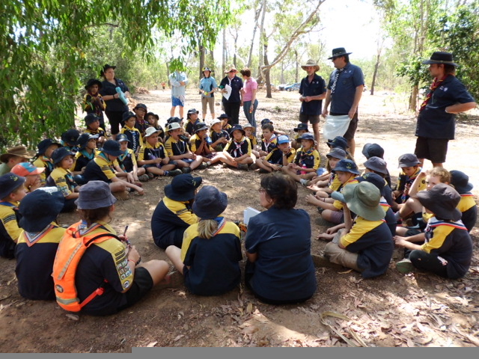

Booking Procedure

1. Phone Scout NT Branch Office on (08) 8948 0994 to discuss availability and pencil in a booking. This must be done well in advance of your intended visit.

2. Office staff will then email you a booking form.

3. Complete and return the booking form to confirm your booking.

4. Fee payment must be arranged prior to collecting keys.

5. You must re-confirm your attendance a minimum of 1 week prior to your booking dates. A few days prior to the booked camp please arrange collection of the key from Scouts NT Branch office.

6. After your stay please return the Woorabinda key to Scouts NT Branch.
(A $50 fee applies for lost keys).

Scouts NT Branch Office operating hours:

Monday 9am – 2pm
Tuesday 9am - 4pm
Wednesday 9am - 4pm
Thursday 9am - 4pm
Friday 9am - 2pm
Saturday Closed
Sunday Closed

Booking forms: http://www.nt.scouts.com.au/Woorabinda

Cancellations

If for any reason you need to cancel your booking, please ring the Scouts NT Branch Office on 08 8948 0994 and inform staff as soon as possible.

Site Information

Site Access

The Woorabinda Youth Campground is closed to general public access offering exclusive use. The Howard Springs Nature Park main gates are open between 8am and 8pm. Woorabinda Campground Users are supplied a key to access the main park gates during closing hours. The Park main gate must not be left open after hours.

If you wish to view the camp grounds please make prior arrangements with the voluntary caretaker via email: gl.woorabinda@nthq.scouts.com.au or through the Scouts NT Branch office on (ph) 08 8948 0994.

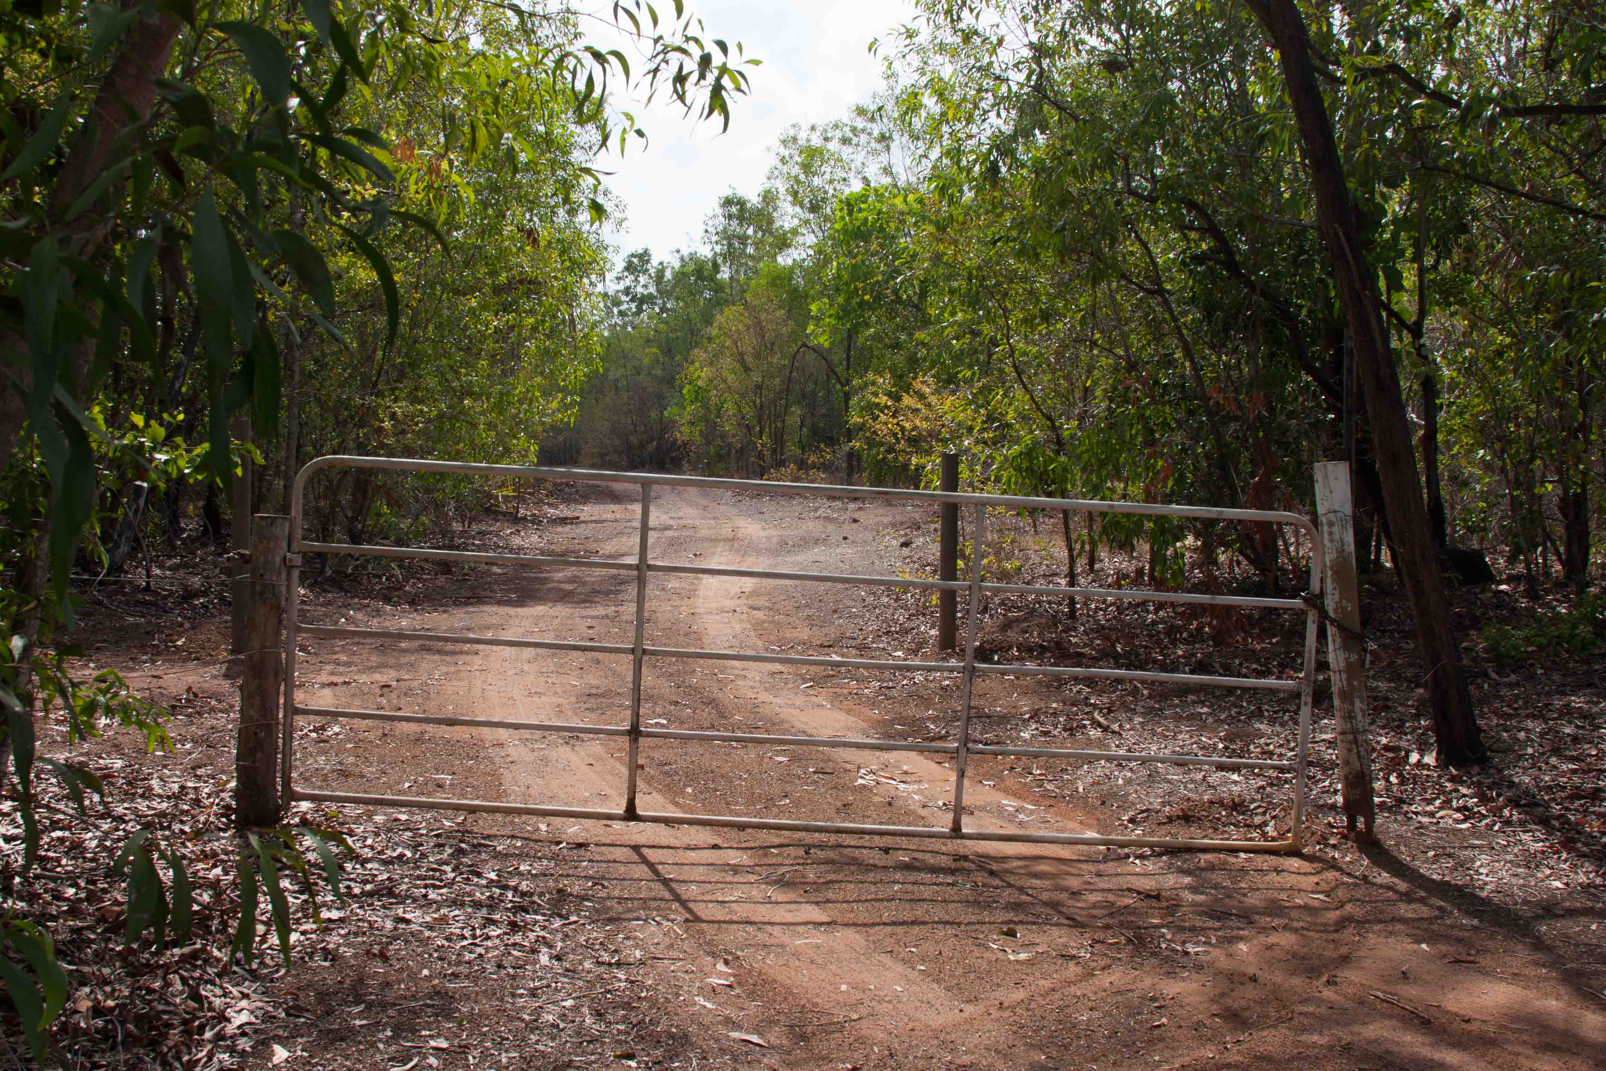

Ablution Block

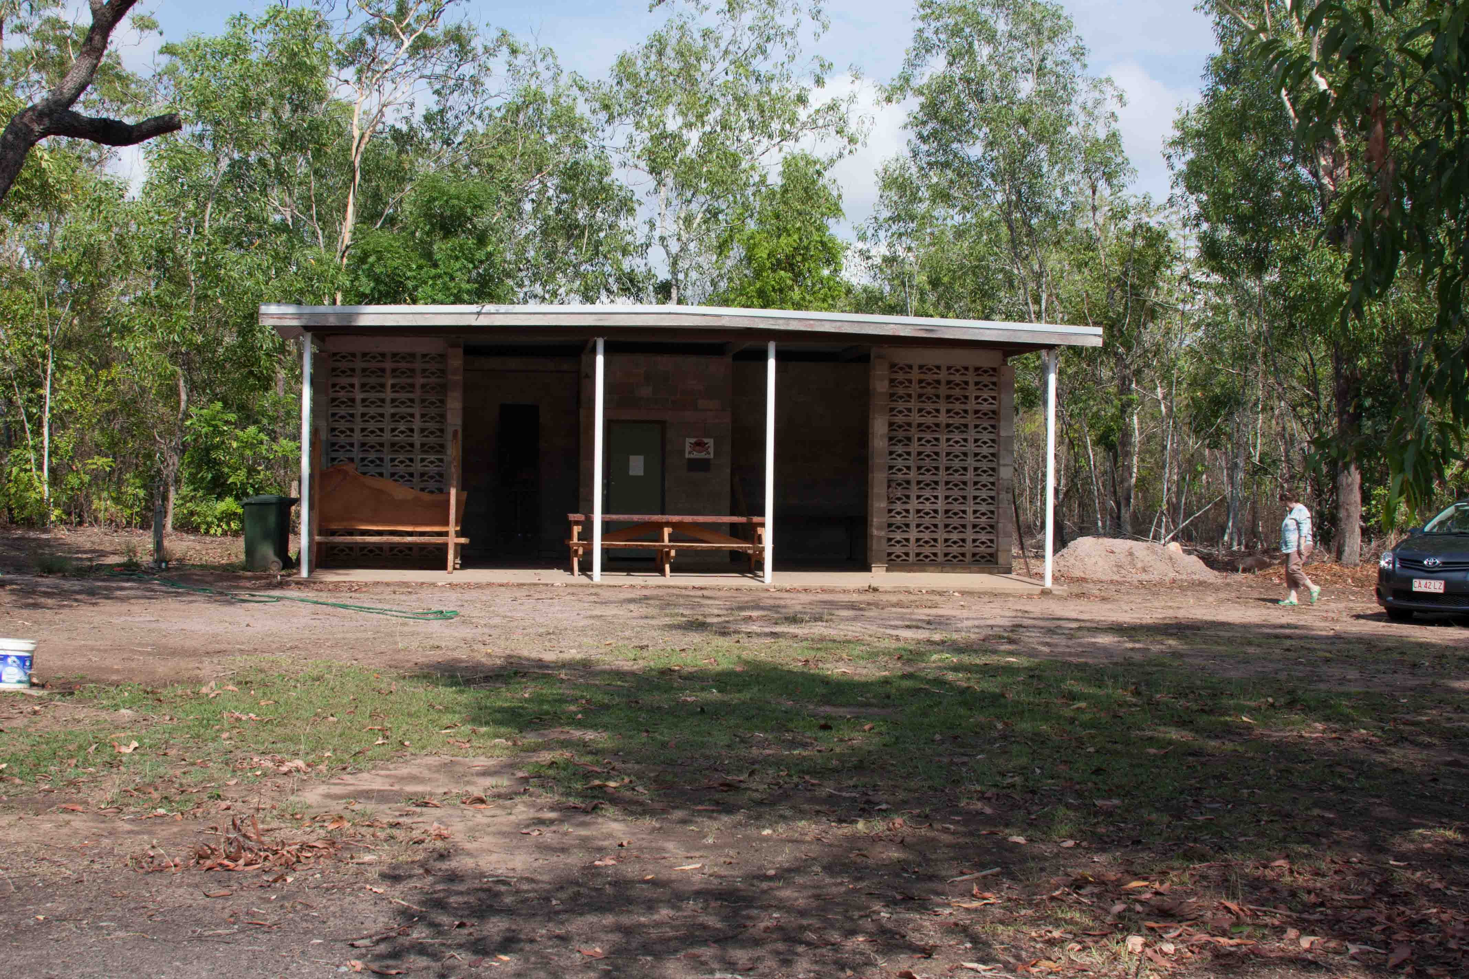

3 unisex toilets
3 unisex showers (hot and cold water available)

Outdoor Kitchen
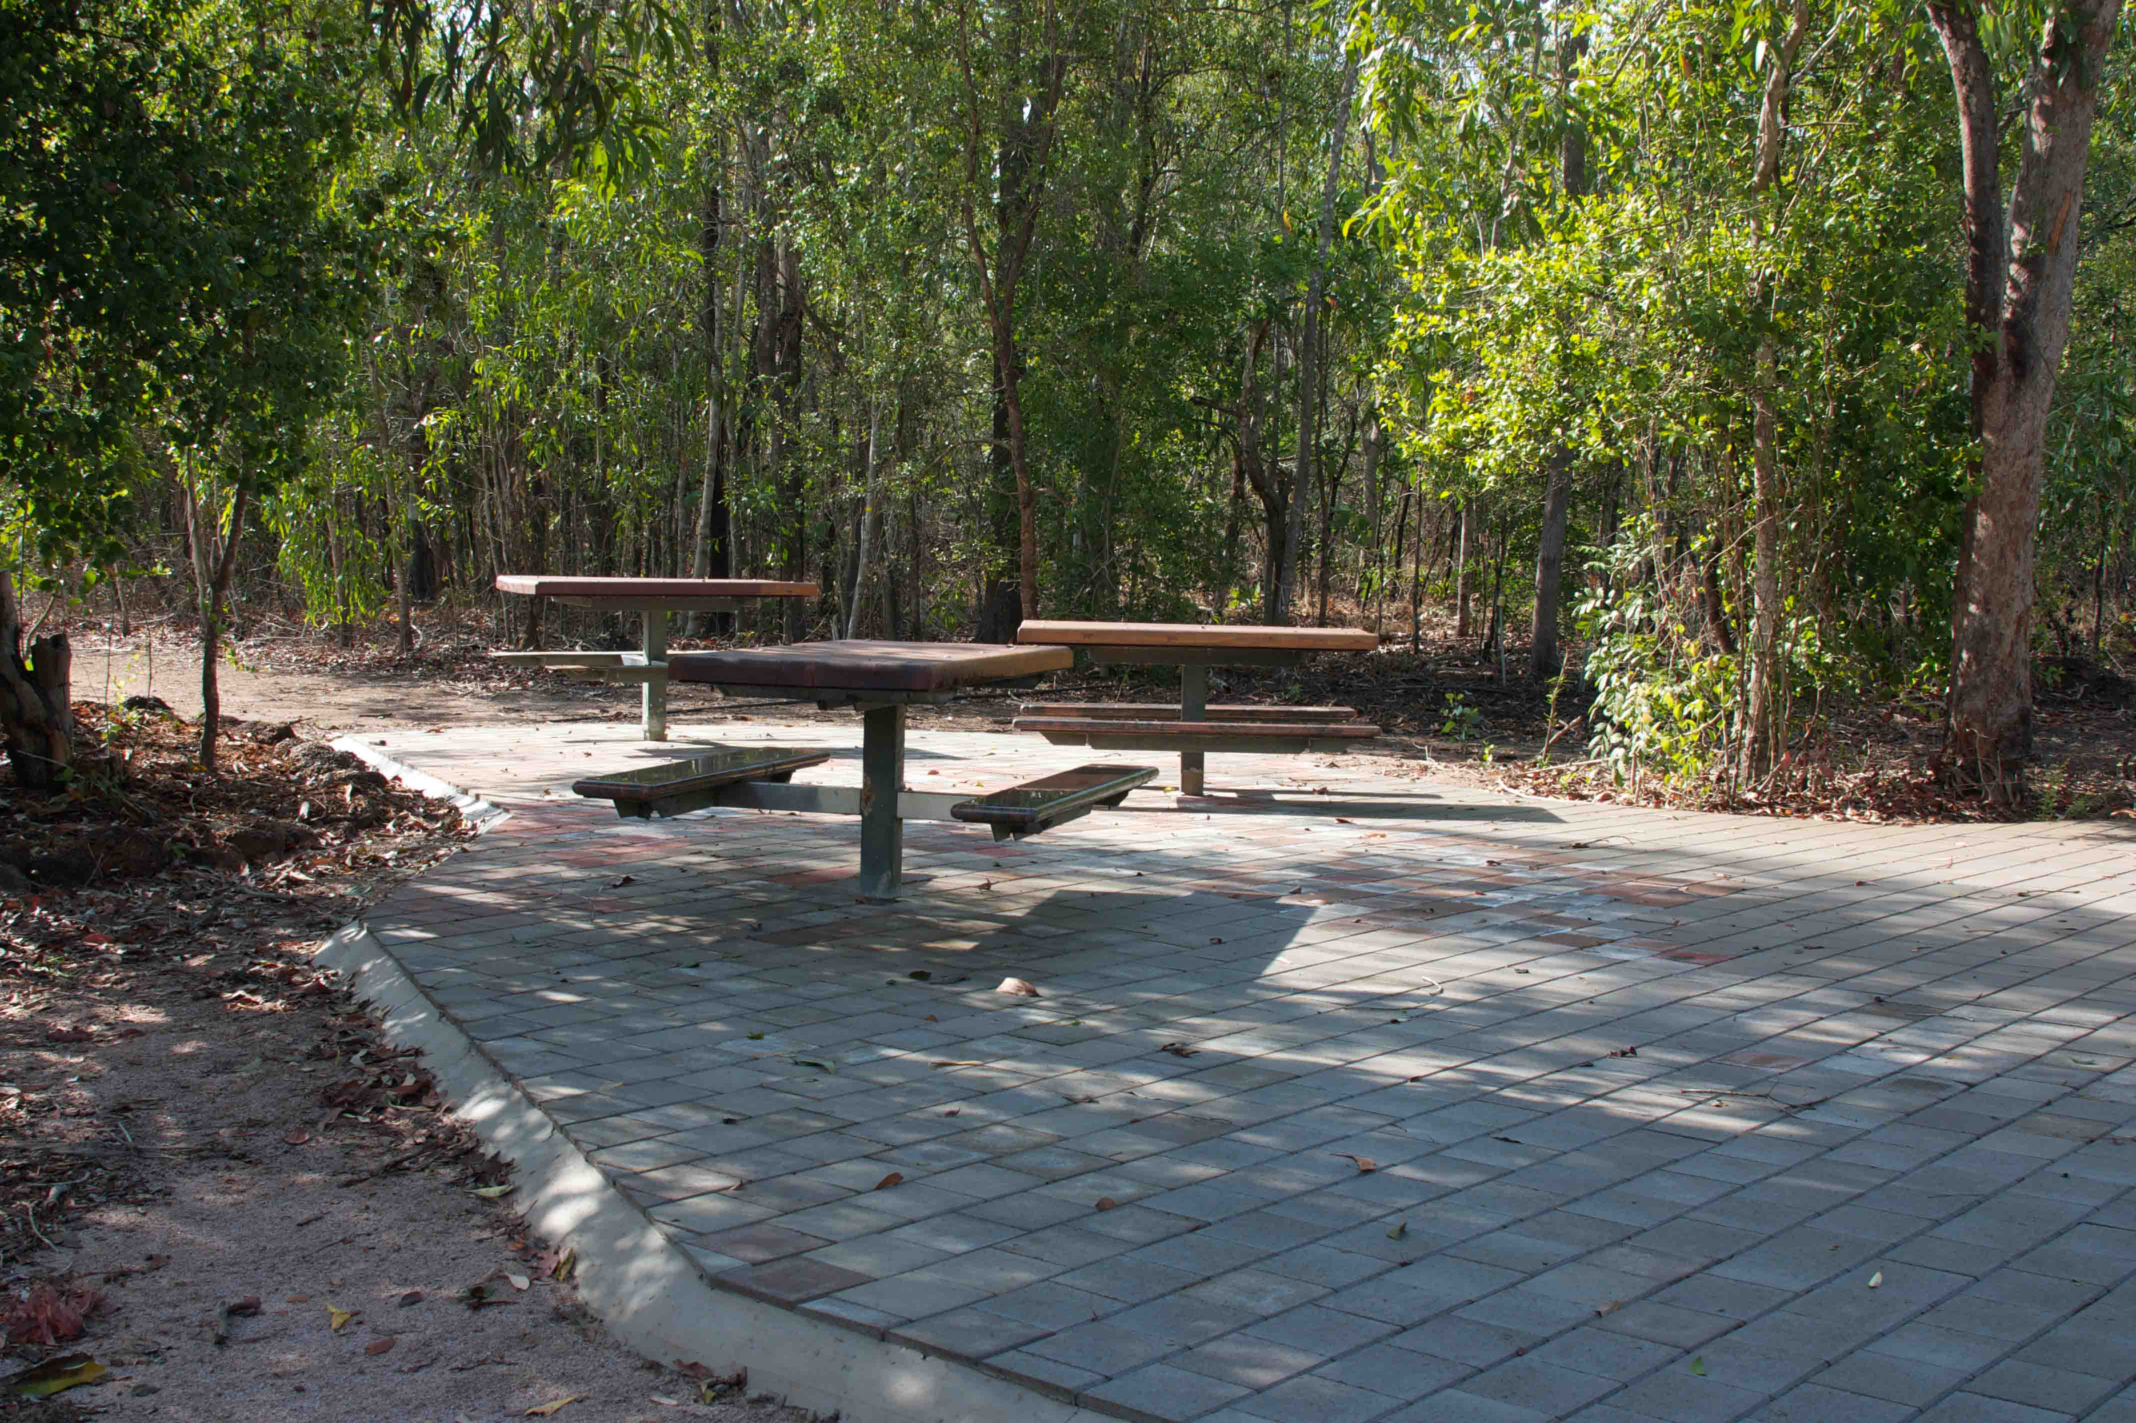

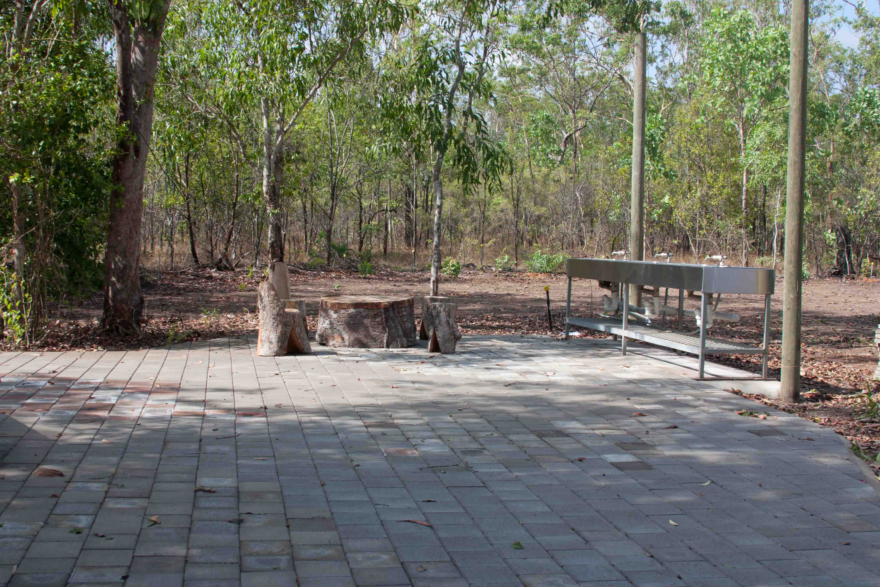

Paved kitchen area with outdoor sinks and picnic tables. A portable gas barbeque is available for use.

Camping Area
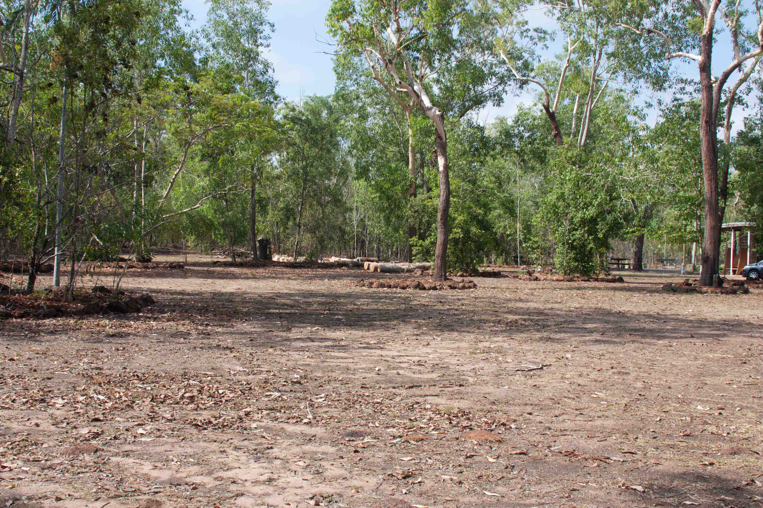

Located adjacent to the amenities block there is a large grassed area suitable for approximately forty (40), two (2) person-style tents.

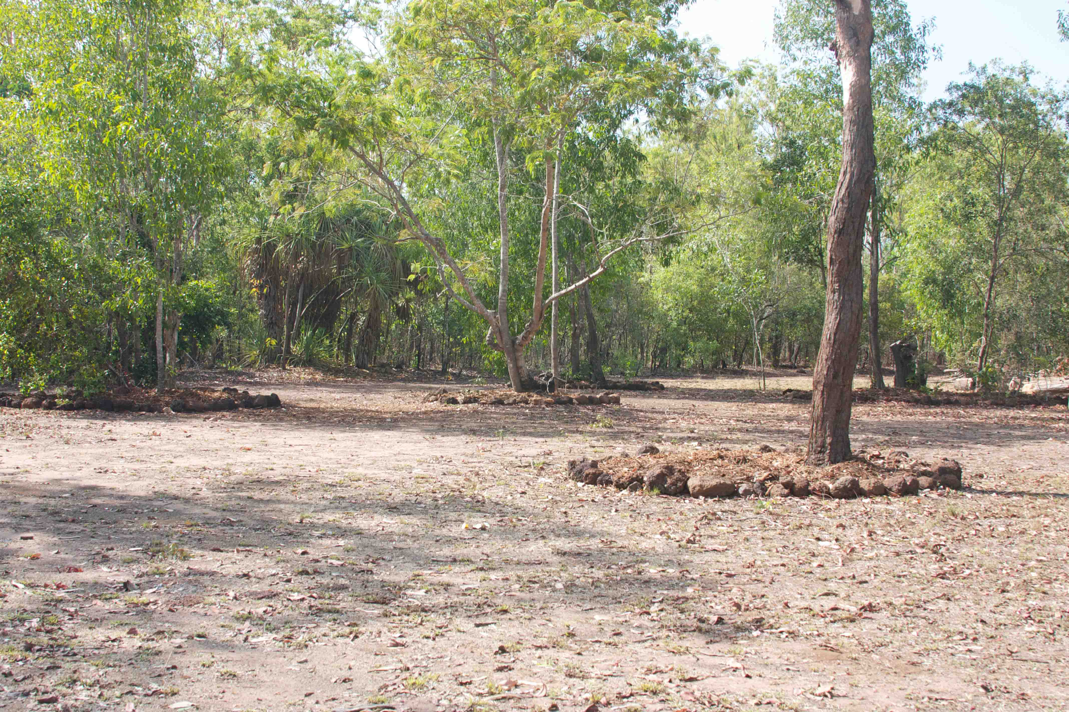

Open Campfire

Large fire pit with seating surrounding it.
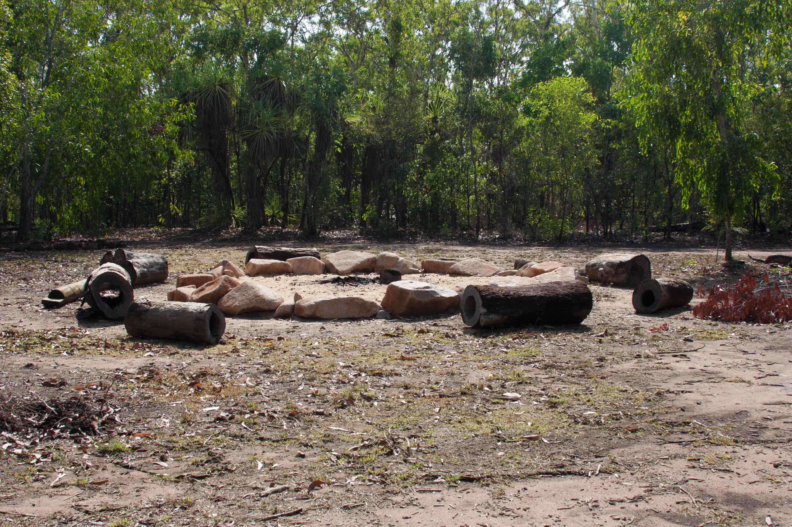

Power

There is no mains power to the site. Solar lights are installed in the amenities’ block. Groups requiring additional power are encouraged to bring their own solar system or generator. Territory Parks and Wildlife Conservation by-laws require a permit for generator use. Users can arrange a permit on pwpermits@nt.gov.au or 89994486. This must be done well in advance of the intended visit. Permits may take up to 5 working days to process.

Water

Water is available in the outdoor kitchen and amenities block; outside taps and hoses are also provided.

Miscellaneous Items

• Rubbish bins and bin liners
• Cleaning agents (disinfectant, mop, buckets, brooms
• Toilet paper
(These items are available in the store area of the amenities block)

Health and Safety

First Aid Kit

Bring a comprehensive First Aid kit adequate for the needs of your group.

Heat Illness

Due to the climate in the Top End we recommend your group do the following: wear loose-fitting and light coloured clothing, use sunscreen, wear a hat, drink and carry plenty of water and walk in the cool of the day.

If engaging in strenuous activities please consider the following information or reference the WBGT index for a more comprehensive guide.

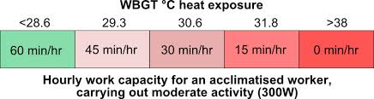

Drinking Water

Water provided at the campsite is mains supplied and is suitable for drinking.

Biting Insects

Protect your group from biting insects:

• Mosquitoes can be present all year, especially on dusk.
• Cover up – wear light, long sleeved / legged clothing.
•Use an insect repellent containing 20% DEET is recommended (tropical strength)
•Wear socks and closed in shoes.
• do not sit or lie on bare ground or grass – use suitable ground cover.
• Use mosquito nets or mosquito proof tents.
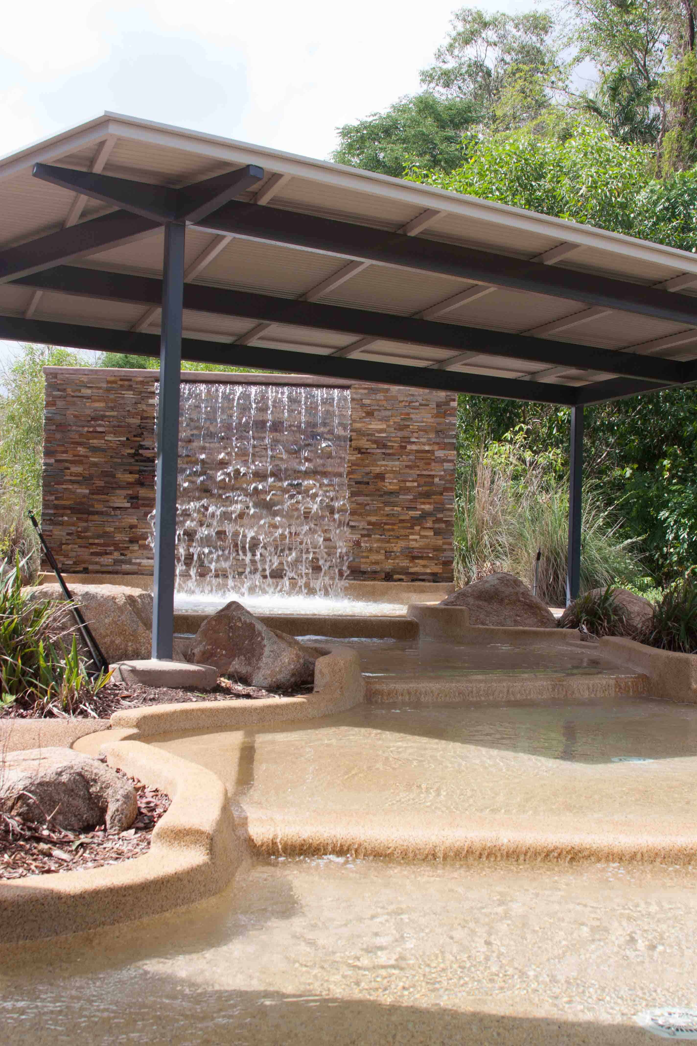
Swimming

There is designated swimming at the Howard Springs Nature Park in the purpose built rock pools. Swimming is not permitted in the natural spring water pool due to unsafe levels of bacteria. Please adhere to all signs.

Swimming areas are not fenced. Please ensure your group is fully supervised while in and around swimming areas. No swimming in the rock pools is permitted prior to 8 am or after 6pm.

Tropical Diseases

Diseases can be acquired from this environment. Protect yourself. Ross River / Barmah Forest Virus is transmitted by mosquitoes, cover up and use a 20% DEET based repellent. If you develop feverish symptoms or feel unwell let your doctor know about the possibility of these illnesses.

Crocodiles

Saltwater and Freshwater Crocodiles are common throughout the Top Ends water systems take note of all warning signs and site closures.

Communications

Mobile Phone coverage is common throughout the park however check with mobile service providers if unsure.

Public Telephones are located at Howard Springs Shopping Centre and Coolalinga Shopping Centre.

Emergency Facilities

There is no after-hours on site caretaker at Woorabinda or ranger presence at the Howard Springs Nature Park.

In the event of a major medical condition, injury or missing person, call emergency services for assistance on ‘000’.

Should a member of your group become ill or suffer a minor injury, a 24 Hour Health Clinic is located at Palmerston Health Precinct, at 3 Gurd Street, Farrar NT 0831. Contact number: (08) 8919891.

This practice bulk bills children aged 0-16 years.

Emergency Evacuation

Please see Bushfire Safety Plan on pages 21 -24.

Your Responsibilities

What to Bring

- Cooking equipment - pots, pans and kitchen utensils
- Crockery and cutlery
- Kitchen cleaning agents (e.g. dishwashing liquid, sponges, scourers, tea towels etc.)
- Teaching aids and play equipment
- Eskies and insulated water storage containers
- Comprehensive first aid kit
- All camping equipment
- All food
- Any extra tables and chairs (beyond those provided)
- Torches
- Generator or portable Solar power system if you require power.

During Your Stay

You are responsible for the general cleanliness and tidiness of the camp and its facilities. Please report any problems, faults or breakages to the caretaker who will arrange to meet you before you leave. Please look after the grounds and facilities as they are provided for everyone’s convenience and enjoyment.

Camp Fires
If you need a fire, light a small one in the fireplace provided. Campfires must not be established outside of the designated fire pit. Please remember that dead timber is part of the natural environment. Only use wood from the woodpile provided and please use sustainably. Campfires are part of the outdoor experience, but don’t let your campfire go bush! Before you light a fire, check local fire restrictions to determine if a Total Fire Ban is in force.
• Don’t light a campfire, or keep one alight, on dry, windy days.
• Clear the ground and air space of flammable material within three metres of your campfire.
• An adult must be present at all times.
• Never leave a fire unattended.
• Extinguish your campfire with water, not soil. When it’s cool to touch, it’s safe to leave.

Food Scraps
Keep the wildlife wild. Do not feed the native animals nor leave food scrapes around; they may change the diets of local animals impacting on their long term health and may also alter the normal wild behavior of animals to create public nuisance.

Rubbish
Bins are provided at the campground, please ensure they are used. If walking - take plastic bags to carry rubbish back to the camp. Do not utilize the Nature Park bins for campground rubbish.

Respect other users of the Nature Park
Please remind all campers that they are within a Nature park and need to be considerate to other users of the area ie noise. Your group must comply with all signs and your acitivities must abide with Park Regulations and By-Laws. Hire of Woorabinda campground does not imply exclusive use of Nature Park facilities, such as the rock pool and playground.

When You Leave

Ensure the grounds are litter free and all rubbish is disposed of in the bins provided.

Kitchen
Ensure that all kitchen facilities and surfaces are clean and the water hose is put away.

Ablution Block
Ensure that all showers, toilets and floors and hand basins are clean and re-supplied for the next group.

Camp Equipment
Ensure that all camp tables and chairs are clean and placed back into the store room.

Education Equipment
Ensure that all education equipment and materials used during the camp are placed back into the storage container.

Educational Opportunities

Natural Environment Overview

Woorabinda and the wider Howard Springs Nature Park provide many opportunities to experience, appreciate and learn about nature. Educational opportunities range from plant and animal identification and habitat studies to broader themes including the flows and cycles of life in natural ecosystems. Cultural awareness opportunities can be explored through study of Aboriginal perspective’s of and connection to the land including the use of the natural resources for medicine and food.

Woodlands

Woodlands cover approximately 85% of northern Australia. These woodlands are dominated by a variety of Eucalypt (Gum) trees whose canopy is well spaced and allows sunlight to penetrate and promote the growth of a variety of shrubs, herbs and grasses. Woodlands vary in their composition depending on their topographic location, the availability of water and suitability of soils. In the Howard Springs Nature Park you will find tall Darwin Stringybark (Eucalyptus tetrodonta), Darwin Woollybutt (Eucalyptus miniata) and Ironwood (Erythrophleum chlorostachys) trees form the canopy. The lower storey plants in these woodlands include Sand Palms (Livistonia humilis), Screw Palms (Pandanus spiralis) and a variety of shrubs but a very tall grass, called Spear Grass (Sorghum spp), is the most dominant. This grass grows very quickly during the wet season and can reach a height of up to 3 metres. As the grass dries it encourages fire into the woodland from April through to December. Many of the plants and animals which inhabit the woodlands have adapted to a cycle of bushfire destruction and renewal. Some plants need fire to help their seeds germinate while some animals feed on the new growth that fire promotes. Within the Howard Springs Nature Park the environment has been protected from frequent burning and some woodland is in the process of transforming into dry monsoon vine forest.

This common woodland habitat is home to many animals including Northern Brown Bandicoots (Isoodon macrourus), Agile Wallabies (Macropus agilis) and Northern Quolls (Dasyurus hallucatus). Regularly seen birds include Redwinged Parrots (Aprosmictus erythropterus), Northern Rosellas (Platycercus venustus), Partridge Pigeons (Petrophassa smithii), Magpie-larks (Grallina cyanoleuca) and a number of Honeyeaters (Lichenostomus spp, Melithreptus spp). In April/May when the Spear Grass seeds begin to ripen many seed eating birds can be seen enjoying the feast that they provide. Reptiles including skinks (Carlia spp, Ctenotus spp), dragons (Diporiphora spp), goannas (Varanus spp), snakes (Liasis spp, Demansia spp) and geckos (Oedura spp, Gehyra spp, Diplodactylus spp) are also common and are often heard escaping through the leaf litter well before they are seen.

Monsoon Forests

Monsoon forests occur in small, widely separated patches across Northern Australia and range from coastal areas to as far inland as Mataranka. They vary in their composition depending on their topographic location, the availability of water and suitability of soils. They occur on rocky outcrops, along coastlines, on floodplains, in gullies and gorges and along watercourses.

In Howard Springs Nature Reserve the monsoon rain forests are associated with the spring and creeks with a year round water supply. They consist mainly of evergreen plants that come in a variety of forms including palms, vines, tall buttressed trees and ferns. The upper storey plants such as Carpentaria Palms, fig trees (Ficus spp) and Weeping Paperbarks (Melaleuca spp) form a dense canopy through which little light can penetrate. A variety of vines can be seen twisting their way up through the canopy. Soft, broad-leaved shrubs and ferns form the vine forest under storey and the ground is covered with leaf litter.

Monsoon rainforest areas are home to many birds including Pied Imperial-Pigeons (Ducula spilorrhoa), Kingfishers (Todiramphus spp, Ceyx spp, Dacelospp), Fairy-wrens (Malurus sp) and a variety of Honeyeaters (Lichenostomusspp, Melithreptus spp). Northern Quolls (Dasyurus hallucatus), Brown Bandicoots (Isoodon macrourus) are common and Black Flying Foxes (Pteropus alecto) may be seen roosting in the branches. A wide variety of skinks, geckos and frogs can be found amongst the leaf litter.
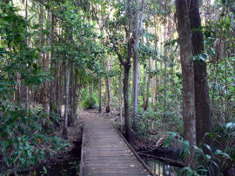

Riverine

Fresh water river systems in the Top End form narrow corridors of lush vegetation that contrast greatly against the much harsher, drier surrounding woodlands. Woodlands along watercourses usually have a denser canopy of trees than other woodlands. Trees may include Leichardt Trees (Nauclea orientalis), Ti-trees (Leptospermum longifolium) and Paperbarks (Melaleuca spp). The canopy created by these trees allows a variety of soft, broad-leaved shrubs and annual herbs and grasses to grow as an under storey. The constant flow of water has allowed large populations of many common riverine plants and animals to become well established. A variety of frogs can be seen (and more often heard after rain) and fresh water fish and turtles can be spotted in the Springs natural pool. Signs along the weir identify the species.

Many birds that rely on a permanent supply of water such as seed eating birds like Double-bar Finches (Poephila bichenovii) and RedwingedParrots (Aprosmictus erythropterus), Australian White Ibis (Threskiornis molucca), Magpie Geese (Anseranas semipalmata), Whistling Ducks, Radjah Shelducks (Tadorna radjah) and Pygmy Geese (Nettapus pulchellus) are never far from water. Reptiles too, take advantage of the abundance of water and the large Merton’s Water Monitor (Varanus mertensi); can be observed around the water hole and creeks.

Activities Overview

Groups should consider the purpose of their camp, and length of visit when planning activities for the camp. Groups are encouraged to bring their own equipment and teaching aids to the camp. Woorabinda Youth Camp is a perfect setting for the following activities:

- Bird watching
- Animal identification
- Orienteering courses
- 1.8 km Creek Bush Walk (subject to flooding during the wet season)
- Bush tucker/bush medicine identification
- Team building activities
- Astronomy/Star gazing
- Camp fire sing-a-long
- Camp fire Cooking
- Environmental Studies
- Conservation activities
- Volunteer maintenance activities

An additional range of activities that campers can participate in are being developed by Scouts NT over coming months.

There are also many quality camping and outdoor activities freely available on education curriculum websites, you are encouraged to research these and develop a unique program suitable to your educational and outdoor recreational needs.

Bushfire Safety Plan
Bushfires can happen at any time, they can start suddenly and without any warning. The dry season (May to November) is considered high risk for bushfires. This coincides with the most popular time for camping. Strong winds are experienced in the top end from July to November. These winds allow fires to move very fast and can also carry burning embers for several kilometres in advance of a fire front.

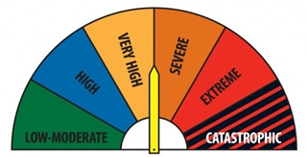

Fire category’s above ‘Very High’ can threaten suddenly or without warning; can burn unpredictably and be very difficult to control. There will be significant noise, radiant heat and smoke associated with these fires. This will make it difficult to see, hear or breathe. It is important for campers to ‘Be Prepared’; to identify fire danger, have a safety plan in place and manage the emergency situation to minimise any injury or loss of life.

Woorabinda is located within the Howard Springs Nature Park. With the exception of the Gunn Point Rd reserve to southern boundary; the remainder of the Nature Park is surrounded by bushland. There is a network of fire breaks within the Nature Park.

Important Contacts:

Howard Springs Volunteer Fire Brigade captain:
Maxine Way 0408 832518
Howard Springs Park Rangers:
Louise Kean 0408 084726
John Papple 0427 009653
Woorabinda Coordinator:
Belinda Brustolin 0408 891737
Procedure for Woorabinda Coordinator

In the week prior to booked camp:

- Check fire rating prediction for camp period
- Cancel any camp booking for days that have a ‘Catastrophic’ fire rating

Procedure for Camp Leader

- Read Woorabinda Bushfire Safety Plan.
- Check fire rating prediction for camp period and take action as per Woorabinda Bushfire Safety Plan.
- DO NOT pitch tents within 10m of fire break or bush margin to avoid blocking access for fire trucks.
- Locate emergency folder in amenities block and place list of camper names in it and hang under Emergency Muster Point sign located on veranda of amenities block.
- All cars should be parked together in an area with minimal vegetation; when not in use.
- Communicate bushfire plan to adults and youth at commencement of camp, ensure all users are aware of 1st muster point and the required response to emergency signal.
- Maintain phone/radio contact with campers who are going off site for activities.
- Educate offsite participants on bushfire safety
- Maintain surveillance for bushfires during period of camp.
- Observe total fire ban requirements.

Off site bush fire safety advice:

- Avoid entering the bush on days of severe, extreme or catastrophic fire danger, or if there is smoke or fire in the area
- Maintain contact/advise location with base camp at Woorabinda and nominate a rescue location
- Look for an area where you can shelter from radiant heat, or where there is less vegetation to burn as the fire will be less intense here
- Seek shelter in nearby buildings or a vehicle, or a large body of water such as a dam. Don't shelter in elevated water tanks
- If these options aren't available, try to find an open space such as a previously burnt area or rocky ground. Clear as much fuel away from you as possible and shelter from radiant heat behind your backpack or a fallen log, or lie face-down under a bank, rock, loose earth, or in a hollow
- Stay low to the ground for fresh air and cover up exposed skin to protect yourself from radiant heat
- When possible, move quickly to burnt ground

In event of bushfire detection:

The best plan is to leave long before the fire is anywhere near you. Once the fire is close, it may block access roads, and smoke will make driving extremely dangerous.

Commence emergency signal – three long blasts from a whistle; continue emergency signal intermittently until all campers are assembled at muster point.

Assemble and check off all campers at 1st muster point - on veranda of amenities block. Contact off site campers and commence agreed bushfire safety plan.

Notify NTFRS of fire and advise NTFRS, Park Ranger and Woorabinda Coordinator that Bushfire Safety Plan has been commenced; advise which muster point campers are assembled at and the location of any offsite campers.

If fire is imminent do not waste time trying to save personal belongings or packing up camp.

If not deemed safe to move campers to 2nd Muster Point then:
- Remain at 1st Muster point – stay calm
- do not enter amenities block – close doors
- congregate on veranda and area immediately in front of amenities block, sit campers down
- turn on available fire hose / connect garden hose to water supply and wet surrounding ground and campers, if available, place wet towels over campers to protect against flying embers
- maintain contact with NTFRS for further advice
If deemed safe to move campers to 2nd Muster Point then do so promptly - commence evacuation of campers by car or by walking down main access road to 2nd muster point at rock pools grassed area (allow 10 minutes for your group to walk the distance).

Await advice from NTFRS / Park Ranger.

Campers may be asked to evacuate the Nature Park completely. The 3rd muster point is suggested as the Howard Springs Scout Hall, next to the Howard Springs Primary School - access by driving along Howard Springs Rd toward the Stuart Highway, turn left into Stow Rd and then left into Whitewood Rd.

Do not attempt to walk out of the Nature Park in event of a bush fire – fires move fast and you may become trapped. You will be safer on the grassed area adjacent to the rock pools/main spring pool until safe transport is available.

Nominated Emergency Muster Points:

These muster points are known to NTFRS and the Rangers of the Howard Springs Nature Park, so in event of an emergency - for your campers safety - please utilise them.

1st muster point – amenities block, Woorabinda Campground
2nd muster point – rock pools grassed area, Howard Springs Nature Park
3rd muster Point – Howard Springs Scout Hall, Whitewood Rd

On days of Total Fire Ban:

• Campfires and open flame barbecues are not permitted. This includes the use of kettle/Weber style barbecues and camp ovens.
• Solid fuel barbecues (e.g. wood, charcoal and briquettes) are not permitted.
• Liquid fuel barbecues or appliances are not permitted to be used in the open.
• Gas and electric barbecues are permitted, provided that:
• The area three metres around the barbecue is cleared of flammable material.
• You have a hose connected to a water supply or vessel with at least 10 litres of water.
• An adult who has the capacity and means to extinguish the fire is present at all times.
• The fire is completely extinguished before the adult leaves.

Scouts NT hope you enjoy your stay at Woorabinda and welcome relevant feedback.

